**MongoDB Task 2**

Creating database for zen classes programme.

Database name: Zen

Collections:

1. users:

{

_id: number,

name: "John Doe",

email: "john@example.com",

codekata_problems_solved: 120,

mentor_id: number

}

1. codekata:

{

_id:number,

user_id:number,

problems_solved: 120

}

1. attendance:

{

_id: number,

user_id:number,

date: ISODate("2020-10-16"),

status: "absent"

}

1. topics:

{

_id:number,

topic_name: "MongoDB Basics",

date: ISODate("2020-10-10")

}

1. tasks:

{

_id: number,

task_name: "Design a MongoDB schema",

date: ISODate("2020-10-12"),

submitted: true,

user_id: number

}

1. company_drives:

{

_id: number,

company_name: "Google",

date: ISODate("2020-10-20"),

students_appeared: [number]

}

1. mentors:

{

_id: number,

name: "Jane Smith",

mentees_count: 20

}

Question 1:

Find all the topics and tasks which are thought in the month of October.

Query:

db.topics.aggregate([

{

$match: {

date: { $gte: ISODate("2020-10-01"), $lt: ISODate("2020-11-01") }

}

},

{

$project: {

_id: 0,

type: { $literal: "topic" },

name: "$topic_name",

date: 1

}

},

{

$unionWith: {

coll: "tasks",

pipeline: [

{

$match: {

date: { $gte: ISODate("2020-10-01"), $lt: ISODate("2020-11-01") }

}

},

{

$project: {

_id: 0,

type: { $literal: "task" },

name: "$task_name",

date: 1

}

}

]

}

}

]);

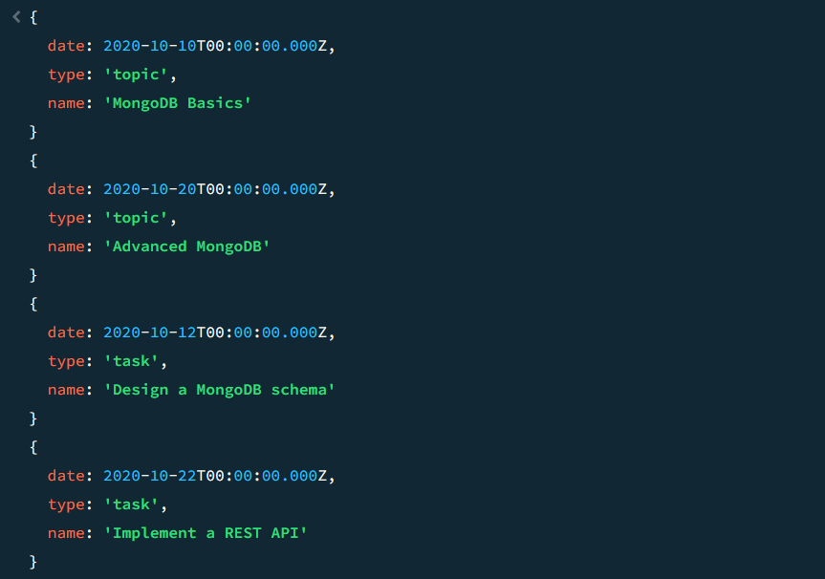

Question 2:

Find all the company drives which appeared between 15 oct-2020 and 31-oct-2020

Query:

db.companyDriver.find({date:{$gte: ISODate("2020-10-15"), $lt: ISODate("2020-11-01")}})

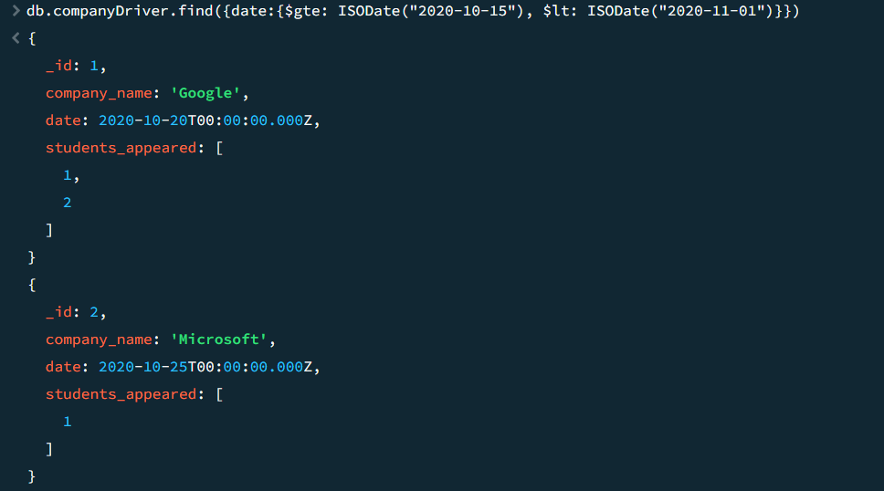

Question 3:

Find all the company drives and students who are appeared for the placement.

Query:

db.companyDrives.aggregate([

{

$lookup: {

from: "users",

localField: "students_appeared",

foreignField: "_id",

as: "students"

}

},

{

$unwind: {

path: "$students",

preserveNullAndEmptyArrays: true

}

},

{

$group: {

_id: "$_id",

company_name: { $first: "$company_name" },

date: { $first: "$date" },

students: { $push: "$students.name" }

}

}

])

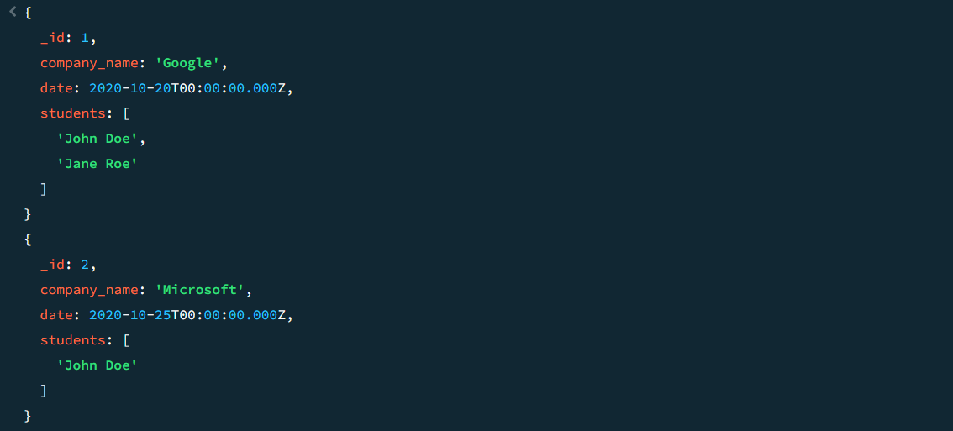

Question 4:

Find the number of problems solved by the user in codekata

Query:

db.codekata.aggregate([

{

$lookup:{

from:"users",

localField:"user_id",

foreignField:"_id",

as: "students"

}

},

{$unwind:{path:"$students"}}

,{

$group: {

_id: "$user_id",

name:{$first: "$students.name"},

total_problems_solved: { $sum: "$problems_solved" }

}

}

]);

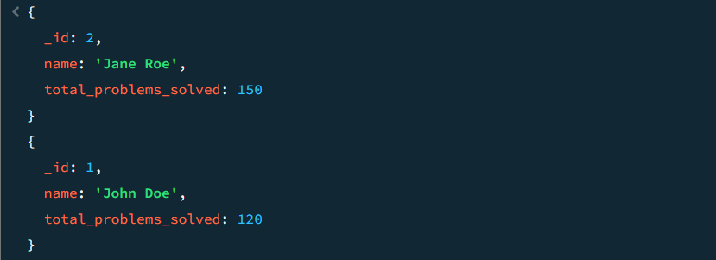

Question 5:

Find all the mentors with who has the mentee's count more than 15

Query:

db.mentors.find({mentees_count:{$gt:15}})

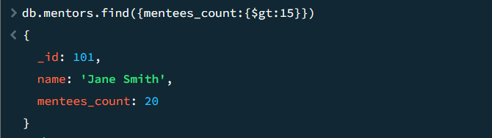

Question 6:

Find the number of users who are absent and task is not submitted  between 15 oct-2020 and 31-oct-2020

Query:

db.attendance.aggregate([

{

$match: {

date: { $gte: ISODate("2020-10-15"), $lt: ISODate("2020-11-01") },

status: "absent"

}

},

{

$lookup: {

from: "tasks",

localField: "user_id",

foreignField: "user_id",

as: "tasks"

}

},

{

$lookup: {

from: "users",

localField: "user_id",

foreignField: "_id",

as: "users"

}

},

{

$unwind: { path: "$tasks" }

},

{

$unwind: { path: "$users"}

},

{

$group: {

_id: "$user_id",

name: { $first: "$users.name" },

attendance: { $first: "$status" },

task_submitted: { $first: "$tasks.submitted" }

}

}

])

